Rain diverter instructions
- Use a ruler or measuring tape to measure a 5 inch gap on the eavestrough.
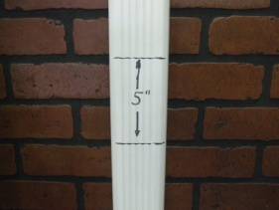
- Use a handsaw to cut open the 5 inch gap to look like this.

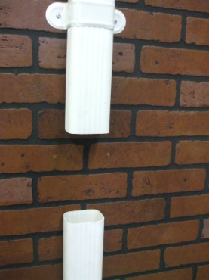

- Place the bottom of the diverter in the bottom of the gap, and then place the top of the diverter in the top part of the gap for a perfect fit.
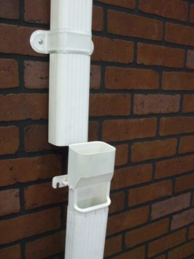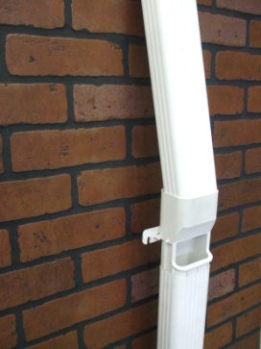

- Now use the diverter to mark the hole positions.
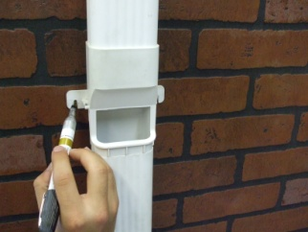
- Use the appropriate drill and drill size depending on what screw you will use. Whether the diverter is being mounted on brick, concrete or wood.
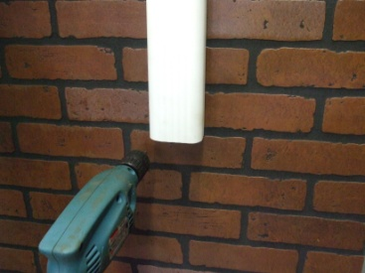

- Use the holes to screw in the diverter.
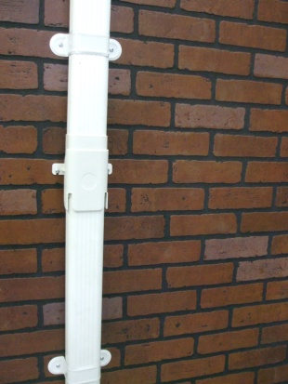

The diverter is now ready to collect fresh rain water. Enjoy!

